The Real Scoop About Spooks!

Haunted In Your House & Heart
presented by
Renee Beese Renowned Mystic Leader

Friday October 28th, 7-9pm
The Time Community Theater Downtown Oshkosh
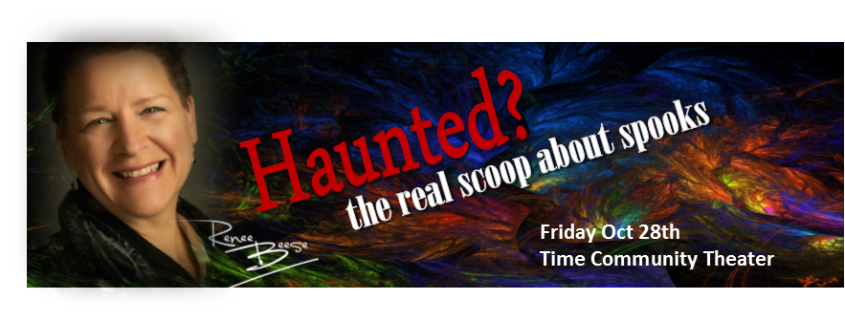
Spirits, Attachments, Crossed, Not Crossed Oh My!
- Know the difference between, spirits, entities (alive or dead), possessions
- What to do, what not to do & what to leave alone
- Intuitive house readings live in the audience
- What crossing over looks like, When someone doesn't cross, What about suicides

Get Rid Of The Ghosts For Good!

Trick & Treat
- First 150 get a trick & treat bag
- Draft beer & popcorn at concession stand
- Wear scary socks & shoes, get em in the shoe cam, win prizes!! Sponsored by Stella & Dot
- Meet before & after for food & drinks @ Bar430 nothing scary here, real food, urban feel
- Get Your Intuitive Painting of Your Spirit by S J Posselt in Appleton on October 28th from 9-4 pm. Contact renee@TheMidwestMystic for your time slot

All Delivered with Renee’s Infamous Wit & Wisdom

Meet & Greet with Renee 6:15 - 6:45 $35 ~ General Seating $25 ~ Balcony $20
Doors open at 6:30 ~ Show starts at 7-9 pm
Tickets @ http://www.TheMidwestMystic.com

Supportive Links:
Check out Renee’s monthly article in Nature’s Pathways, her past events tab and press releases at http://www.TheMidwestMystic.com

Event Sponsored By: Stella & Dot, Bar 430, Essential BodyWear, Natural Boutique, Cocoon Beautiful

About Speaker:
Renee Beese is an expert in her field of energy arts, intuitive clarity & empowerment skills. A born intuitive, her profession began in 1998 in Oshkosh. Renee integrates: her natural gifts, 30 years of mystic and traditional training, and her dynamic personality to get to the root of what is wrong while delivering specific solutions in Love ~ Health ~ Wealth ~ Work ~ Kids & Pets Too! Prepare to be entertained and without knowing how or why, be changed for the better.

Contact:
Renee Beese, 920-651-0625, Renee@TheMidwestMystic.com

http://www.Twitter.com/ReneeBeese
http://www.Facebook.com/Renee-Beese-Midwest-Mystic-1100971523280419
http://www.TheMidwestMystic.com

